
phgy311
lecture #: | date: | professor:
17 | October 23, 2006 | Dr. Haghighi
18  19  20 | October 25, 2006  October 27, 2006  October 30, 2006 | Dr. Haghighi  Dr. Haghighi  Dr. Haghighi
announcements:
- Sorry about the delay everyone! Due to the slides not being posted last weekend we were unable to get the edited ntcs out until now.
- Physio Semi-Formal – November 9th at The 940. Tickets are $35 and include dinner, drinks, dessert and entrance to the after party.

Edited By: Steph Rolin
Do Not Redistribute
set #6
PHGY 311 - Lecture 17 Monday, October 23rd, 2006
Writer: Michelle Laneuville Dr. Haghighi
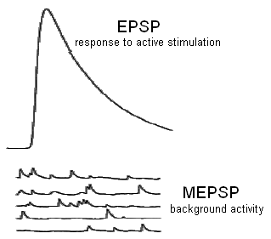

Review of Quantal Analysis

Quantal analysis is a technique which measures the strength of a synapse. Specifically, it measures:
- How the synapse works spontaneously
- The background activity (MEPSP).
- How the synapse will react to active stimulation (EPSP).

Neurotransmitter is not released gradually. It is released in quantal units.
- This quantum size (amount of neurotransmitter in a vesicle) never changes unless you have a mutation affecting how vesicles are filled.
- The response to a quantum of neurotransmitters (MEPSP or MEPSC) can be different if there’s a change to the postsynaptic receptors, such as a longer or shorter binding time to ACh receptors. The longer a channel is open, the more charges accumulate (ΔQ) and the larger the membrane potential change.

We can calculate m, the number of vesicles being released after a presynaptic stimulation, using the following equation.
m = mean EPSP = mean EPSC
mean MEPSP mean MEPSC

NMJ Mutations in Drosophila

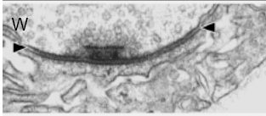
In this picture of a wild type cell (W), we can see:
- The active site (dense material)
- Where the neurotransmitter vesicles are released.
- The junctional folds in the postsynaptic membrane
- Where the postsynaptic receptors are located.
- The neurotransmitter vesicles accumulating and docking.
- Ready for release.
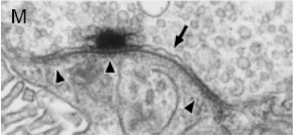
To understand neurotransmitter release, we inspect mutant forms of the system and Note the difference between the mutant cell (M) on the left, and the wild type cell above.

Abnormalities in the mutant presynaptic membrane:
- Active site not as clear and tight as normal.
- Neurotransmitter vesicles are not as well accumulated.
- Problems in muscle folds.
- Remnants of vacuole.
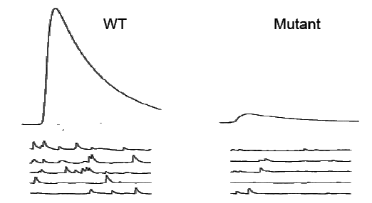
In order to understand the effects of these mutations, we inspect the MEPSPs and EPSPs of both cell types.
- The mutant cell still has some background activity, but it is greatly reduced.
- EPSPs in the mutant cell are much smaller.

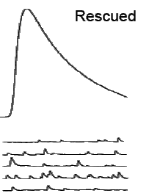
We can rescue these cells by reducing expression of the gene responsible for the mutation.
- MEPSPs and EPSPs resemble those of the wild type cell.
- The cell has been brought back to normal function.

Remember: To measure MEPSP, you don’t need to activate the presynaptic membrane. It is done by passive diffusion of the vesicles through the membrane. Evoked action (EPSP) is dependent on Ca²⁺.

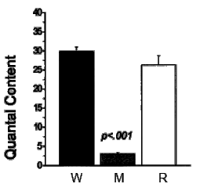

We want to understand why the mutant cells are exhibiting this type of behavior.
- We measure quantal content and notice that it is greatly reduced in the mutant cell.
  - This could be caused by decreased sensitivity to calcium, or a problem affecting neurotransmitter release.
When we rescue cells, quantal content returns to normal.

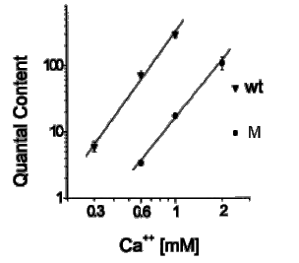
The importance of the EPSP’s dependence on calcium is illustrated by the strong linear relationship between calcium concentration and quantal content.
- When looking at this graph, the mutant doesn’t seem to be affected by intracellular Ca²⁺ concentration sensitivity. There’s still a strong response and m is increasing linearly.
- If the sensitivity to calcium isn’t affected (as seen in a mutation in synaptotagmin) then the mutation in the presynaptic membrane has probably caused a problem with neurotransmitter release.

Mean Open Time Mutations

Single channel kinetics underlie the differences in quantal size.
- Inspecting behavior of single channels will increase understanding of a cell’s response to different stimuli.

The amount of time single channels remain open is very important, as it determines the amount of charge allowed to pass through the channel.
- Channels that open and shut very quickly will barely allow any ions to pass through.

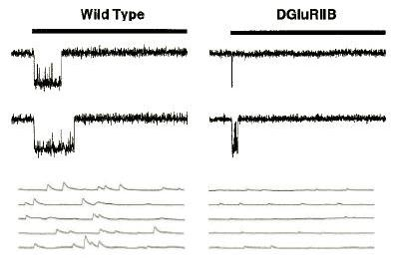
A mutation affecting mean open time will significantly alter the behavior of a cell.

Mean open time of single channels can be altered changing the subunits of a channel.
- To the left, we have a wild type GluR and a mutated channel, DGluRIIB.
  - The mutation affects the mean open time, which affects the MEPSP.

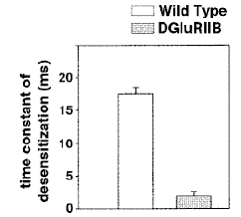
If the mean open time is decreased:
- The opening time is shorter (the time constant of desensitization is smaller), so there is a reduced chance of having more than one channel open at once.
- Mean amplitude of the MEPSP will decrease.
- By decreasing the mean open time, you’re decreasing the amount of charge that comes into the cell (ΔQ) because the amount of time (Δt) has decreased.
- Therefore the depolarization will decrease as well.

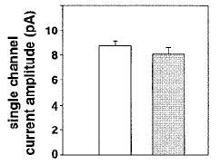
Note that the single channel current amplitude of the stimulated current (I) stays constant no matter what the open time is.
- Extracellular and intracellular ionic concentrations remain constant, so the amount of charge coming into the cell (ΔQ) per amount of time (Δt) remains proportional.

For quantal analysis, the underlying cause for any changes is the opening and closing of neurotransmitter-gated channels.
- If you see something abnormal postsynaptically (in terms of MEPSPs), it’s usually a change in the postsynaptic receptor response.
- It could be a change in the receptor, a change in the mean open time or a change in desensitization.

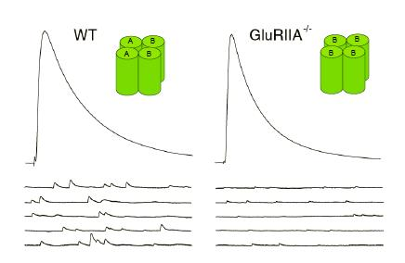
Retrograde Synaptic Compensation

GluRIIa mutant
- The mutant receptor consists mostly of beta subunits (DGluRIIb), which have a shorter mean open time than the alpha subunits.
  - Gives rise to a smaller mean amplitude of MEPSPs (or MEPSC).

However, the EPSP response in amplitude is almost identical.
- The reason for this has nothing to do with a change in channel functioning or with action potentials. The response is the same because more neurotransmitters are released by retrograde synaptic compensation.
- The presynaptic cell is compensating for the mutation in the postsynaptic cell by releasing more neurotransmitter, which will elicit the same postsynaptic response as seen in a wild type cell.
- So if there’s a reduction in the activity of the receptors, the muscle is not satisfied by the amount of depolarization it’s receiving during background activity.
- The muscle needs this depolarization to be able to contract. It communicates to the presynaptic neuron that it is not receiving enough stimulation. In response to this cross talk, the neuron releases more neurotransmitter than it would normally.
- Verify this by calculating quantal content.

Wild Type:
m = mean EPSP/ mean MEPSP = 30 mV/ 0.85 mV = 35

GluRIIa:
m = mean EPSP/ mean MEPSP = 28 mV/ 0.32 mV = 87.5

So how do we determine this is a presynaptic or postsynaptic change?
- Voltage clamp would show a difference in quantal content, but you can’t identify it as a presynaptic or postsynaptic problem.
- You could measure it by the increase in membrane capacitance, but the presynaptic terminals are so small that it would be impossible to do.
- You use failure analysis, because it will slow down the mechanism so only one vesicle is released at a time and then we can see the true increase in quantal content.

Even with different calcium concentration, the change is the same.
- MEPSPs are smaller.
- Quantal content is increased.
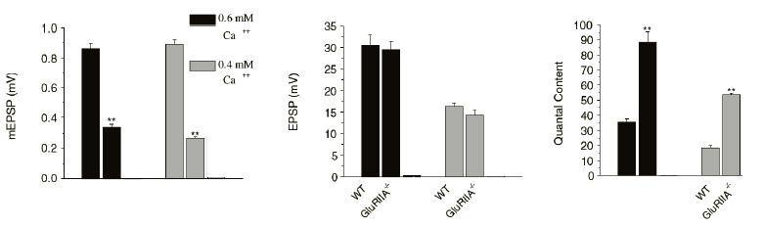
Therefore the retrograde synaptic compensation is independent of calcium.

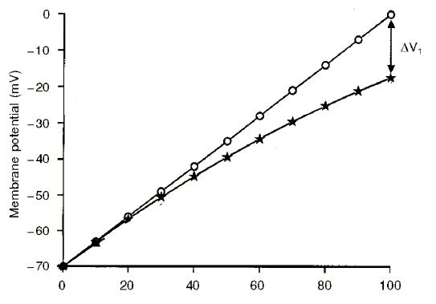
Non-Linear Summation

When you try to predict the membrane potential change with the amount of current generated during an EPSP, you’ll find that there’s a difference between the predicted values (linear line) and the experimental values (curved line).
- We refer to this problem as non-linear summation.

Two main causes of non-linear summation:
- Decrease in the driving force.
- The cell is responding to neurotransmitters, creating an inward current through neurotransmitter-gated receptors, thus depolarizing the cell.
- As the membrane becomes depolarized, it approaches the reversal potential of the neurotransmitter-gated receptors, so the driving force decreases.
- This is a normal negative feedback response, since the cell is trying to reduce the amount of current coming in through the receptors.

- Increase in leak membrane conductance.
- Any increase in current will have this effect on the membrane.
- Leakage decreases the amount of charge separation (ΔQ) and thus lowers the amount of membrane potential change you might expect.

Whenever you measure quantal content using the size of the EPSP, you always have the problem of non-linear summation. This is why you need the voltage clamp.
- If you let the membrane potential change, it will change in response to the current itself.
- Since Vm will never stay constant, you can’t measure the precise current at a precise membrane potential.

The larger the EPSP, the larger the difference between predicted and experimental values.
- This is because the larger the current is, the more leakage in membrane conductance and the lower the driving force.

You should always use MEPSCs and EPSCs to measure quantal content.
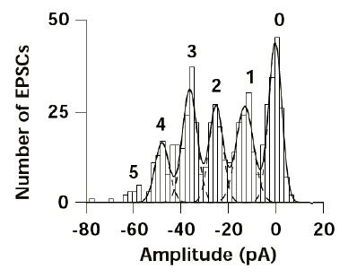
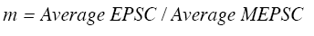
- Paper from 1998, showing measurements of EPSCs and MEPSCs from a CNS neuron.
- The first peak after zero in failure analysis is the mean amplitude of MEPSCs (the 1 on the graph).
- In this case, the mean amplitude is -17 pA.

Answer to the First Question in the Quiz

As soon as he says “the postsynaptic ACh receptors are equally permeable to both Na⁺ and K⁺ ions”, you should know gNa/gK = 1. Even though permeability is not the same as conductance, the ratios are similar.
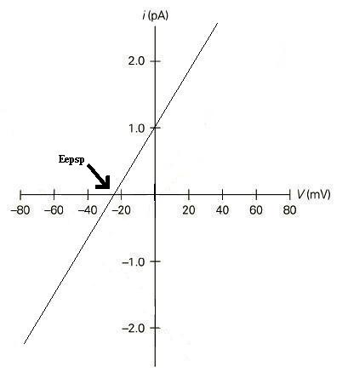
- gNa/gK = 1
- E_{EPSP} = E_{Na} (gNa/gK) + E_{K} = -25 mV (reversal potential, point at y=0 on graph).
(gNa/gK) + 1
- g_{EPSC} = 40 pS x 1000 channels x 100 quanta = 4000 nS

1 ACh channel 1 quantum
- EPSC = g_{EPSC} (Vm – E_{EPSP}) = 4000 nS (-80 mV – (-25 mV)) = 220 nA
- I at –80 mV = 40 pS (-80 mV – (- 25 mV) = -2.2 pA
- I at +40 mV = 40 pS (+40 mV – (-25 mV)) = 2.6 pA

PHGY 311 – Lecture 18 October 25, 2006
Writer: Renata Sasson Dr. Haghighi

Introduction
- Recall that quantal content is how many vesicles are released due to stimulation of presynaptic terminal
  - There are three different ways of measuring quantal content:
    - Mean EPSP/Mean MEPSP
    - Failure analysis (m = ln [N/n₀])
      - N = number of trials, n₀ = number of failures
    - Mean EPSC/Mean MEPSC
      - More accurate due to non-linear summation
- Many more vesicles are released per action potential at NMJ (hundreds) than at CNS synapses (around 5)

Quantal Content
- There are many ways to measure quantal content, but here are two we’ve talked about so far:
  - Failure analysis includes every event in response to the stimulation, including some zeros (failures)
    - Good for comparing quantal content between two synapses (how much more is released from one synapse relative to another)
  - The other way (Mean EPSP/Mean MEPSP) does not have any zeros. You only include trials where NT was released.
- Quantal content depends on Ca++ concentrations, so you cannot compare QC values unless the two were obtained under the same Ca++ conditions.

- Question: “What determines the size of the EPSP at the synapse?”
  - Properties of the presynaptic terminal (number of active zones, available vesicles, how well it recycles its vesicles, size of button, etc.) determine the size of the EPSP presynaptically.
  - Postsynaptically, the size of the EPSP is determined by membrane properties, behavior of postsynaptic receptors, etc.
- At low calcium concentrations, NT release is not always an all or none event.
- In tightly regulated conditions the synapse will sometimes not have enough Ca++ to release NT, which results in “failure” of the synapse.
  - The ratio of times it releases to times it fails gives us an idea of how well the synapse is releasing NT.

Sample Question

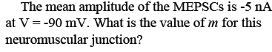
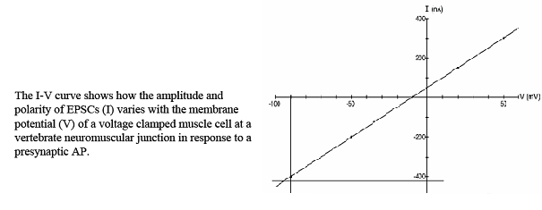
- Recall that m = Mean EPSC/Mean MEPSC
  - We need the mean EPSC at -90mV
- Look at the graph. At -90mV, the EPSC amplitude is -400 nA.
- m = -400nA / -5nA = 80

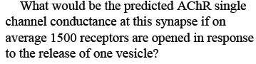
- First, solve for the conductance of the MEPSC. Make sure I and V correspond.
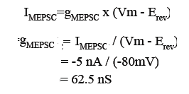
- This is due to 1500 single channels. Divide this by 1500 to find the AChR single channel conductance.
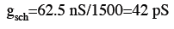

Nonlinear Summation
- One would expect EPSP to change linearly, since the synaptic current also changes linearly. However, as the membrane becomes more and more depolarized this is not what is observed.
  - With increasing depolarization, EPSPs become more inaccurate as predictors of synaptic current because of:
    - Decrease in driving force with more inward current, and
    - Increase leak membrane conductance
- There is an equation that can be used to compensate for this inaccuracy:
  - Corrected EPSP = V’ = V * |(1-V/E)|
    - E = the difference between Vm and E_{rev} for the synaptic current
  - Always use the absolute value of V’ (what matters is the ratio, not the sign) however, it’s unlikely you’d ever get a negative value.
- Smaller the EPSPs are a lot more accurate predictors of quantal content than large EPSPs

Sample Question: Using the Nonlinear Summation Correction Formula
- Two sets of recordings at two different Ca++ concentrations
  - As we know, Ca++ concentration is necessary for evoked NT release, so EPSPs (and quantal content) depend heavily on this.
  - MEPSPs are not affected by calcium because they are passive and spontaneous.
- See slide
- Calculate m for each calcium concentration and each measurement type, using EPSP and EPSC
  - Notice the discrepancy between the values of m obtained with EPSP versus those obtained with EPSC
  - Compare these values with the corrected EPSP value…see slide below!!!
- EPSC is a more accurate measurement than EPSP
- Basically, the point of this example is to show that:
  - it is important to do the correction when measuring quantal content with EPSPs
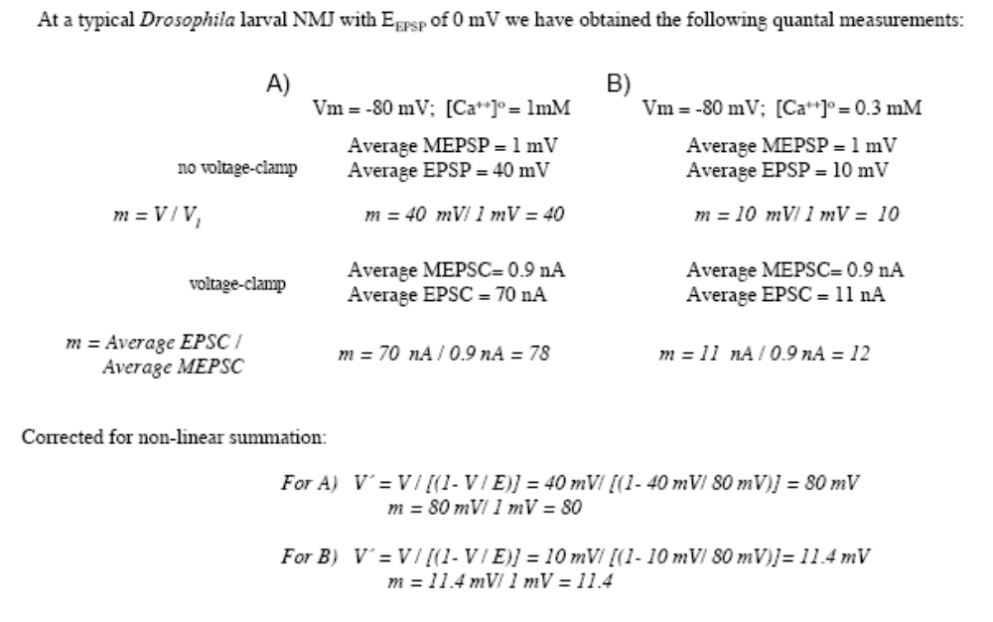
- NOTE: You do not need to do the correction if you measure with EPSC

Review of Quiz (continued from last class)
- Permeability vs. Conductance (question 1)
  - Although permeability and conductance are not the same thing, the ratio between permeabilities is the same as the ratio between conductances.
  - For example: if the membrane is equally permeable to Na+ and K+, this means that gNa and gK are equal.
- Synaptotagmin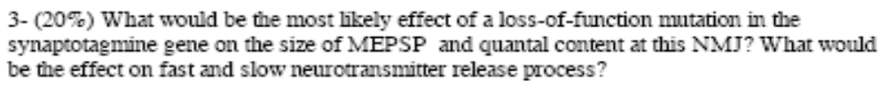
  - Synaptotagmine senses calcium levels, so it is necessary for NT release
  - If inhibited…
    - Would not affect MEPSPs because they do not use NT release machinery.
    - Would decrease EPSPs because they depend on increased Ca++ concentrations being detected.
    - Would decrease quantal content because mean EPSP would be decreased.
    - Would affect fast and slow pathways because both use the active NT release machinery.
- Increased Mean Open Time
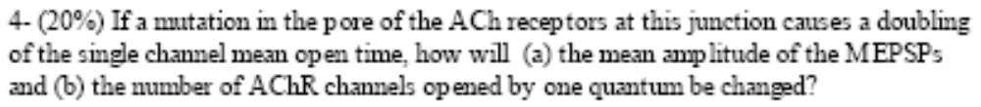
  - More charges will enter post synaptic cell in response to presynaptic NT release.
    - Longer lasting current gives rise to bigger change in potential
  - Number of Ach receptors opening in response to a quantum will not change. It has nothing to do with mean open time. It has to do only with the number of NT molecules released.
- Bonus Question (see slide on next page)
  - Why isn’t there a current during the depolarization?
    - Narrow down which ion the current must be…since Na+ and K+ are blocked, must be Ca++.
    - If you look at a calcium IV curve, you will see that calcium current takes a little while to kick in.
    - Membrane potential is very close to E_{Ca++} so the driving force is low, therefore no current goes through until driving force is high enough (when cell returns to resting potential)
      - As soon as returns to -70mV, get a huge Ca++ current, but it stops quickly because the cell is being held at a hyperpolarized level, which shuts down these Ca++ channels (they’re voltage-gated)

  - Drawing the postsynaptic current:
    - Many people had little blips above the line, which indicate outward current, but that is incorrect.
    - Postsynaptic current should be an inward current (should be drawn below the line)
    - Answer: draw a postsynaptic EPSP that is inward (down) and occurs just after the calcium current ends. (see drawing on slide for an approximate visual)
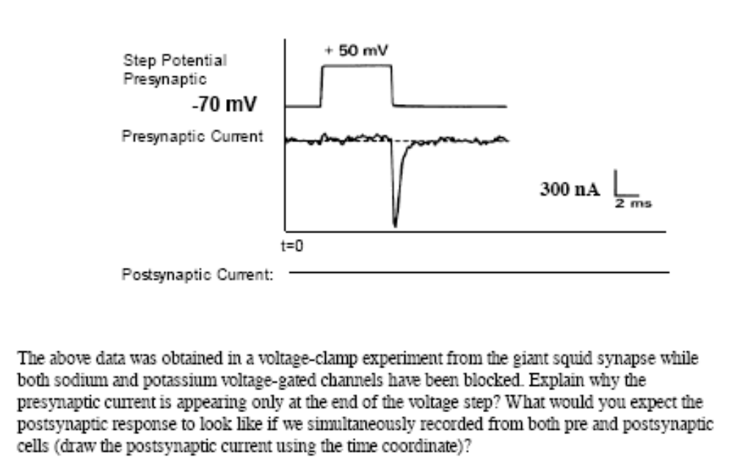

- “This quiz we were quite lenient in marking.”
  - In the future, in order to receive full credit you must explain every step of your thought process. Answers with no work or explanation will not get credit.
- The problem seems to be that people are not dwelling on the slides enough. Many slides seem easy at first, but they’re not.
- It is EXTREMELY important to read the textbook. Many of the quiz questions are straight out of the book.
  - Chapters 10-16 have been assigned for this section.

PHGY 311 - Lecture 19 October 27, 2006
Writer: Renata Sasson Dr. Haghighi

Correction for Non-Linear Summation Revisited
- Calculating m using EPSPs and MEPSPs loses accuracy as we increase depolarization.
  - Must use a correction to adjust for non-linear summation.
- Recall equation: V´ = V / |(1- V / E)|
  - E is the difference between Vm and Erev for the synaptic current
- Essentially, E is the driving force and V is the peak of the EPSP.
  - Why wont V ever be bigger than E?
    - Because before reaching that point, the current will reverse so you will never get V bigger than E
- Note that EPSPs do not account for driving force.
- We can also avoid nonlinear summation by using the voltage clamp and measuring EPSCs and MEPSCs.

Modes of Synaptic Contact between Neurons
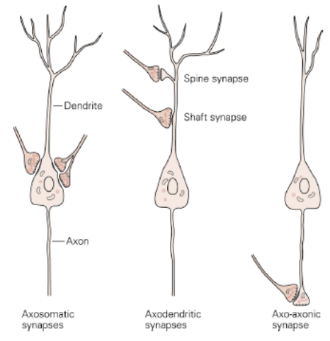
- Connections between neurons are not usually one presynaptic neuron to one postsynaptic neuron in an excitatory or inhibitory stimulus. They’re much more complex than that.
  - There is a temporal aspect and a spatial aspect to this as well.
- There can be many synapses on a single neuron, as depicted to the right
  - Axosomatic - on cell body, usually inhibitory
  - Axodentridic – can be either on spine or on shaft
  - Axoaxonic – on the synaptic terminal, this has the ability to significantly modulate the behavior at the terminal
- The number, placement, and activity of these synapses determines the net response of the neuron.
  - Excitatory input can have a different effect depending on whether the synapse is on a dendrite or on the cell body

Synaptic Integration
- Length and time constants should be reviewed.
  - See chapter 7 from Cooper’s section
- We usually want to know if the signal will lead to an AP and NT release.
- Net response of neuron depends on numerous factors
  - Main factors: size, location and shape of the synapse and proximity and relative strength of other synergistic or antagonistic synapses.
- In diagram at the bottom left, recordings were taken at the dendrite (V1) and at the cell body (V2).
  - Both currents are identical when measured at their site of initiation. However, note that the input coming from synapse A (top) decays almost to nothing before reaching the soma.
- The closer the synapse is to the trigger zone (axon hillock), the stronger input.
- The ability to reach threshold changes in different regions of the neuron
  - Depends on concentration of Na+ channels
- Question: Why does a depolarization only cause an AP at the trigger zone and not before while it is in the cell body?
  - The trigger zone has the greatest concentration of Na+ channels, and therefore it is easiest to reach threshold.
    - The soma has the lowest concentration of Na+ channels.
  - See diagram at bottom right.
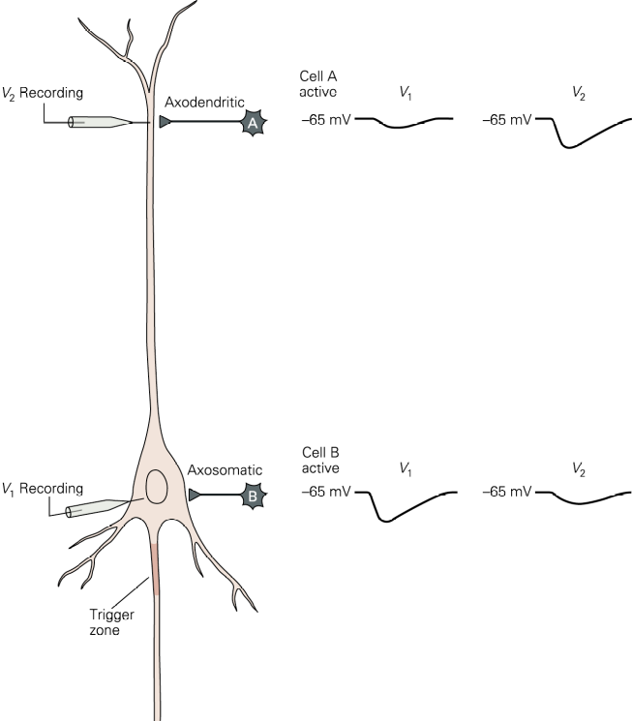
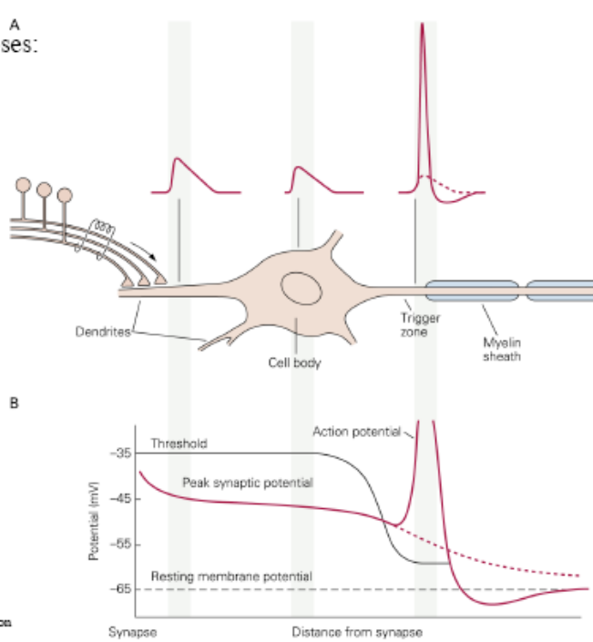

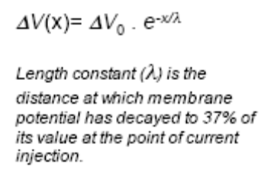
- Recall from Dr. Cooper’s section, the farther away you record from a synapse, the less change in voltage you will measure. 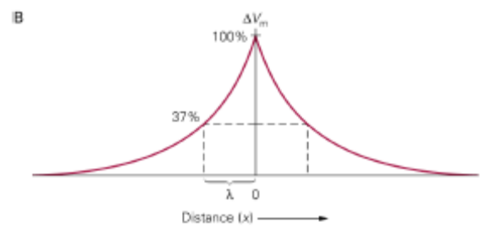

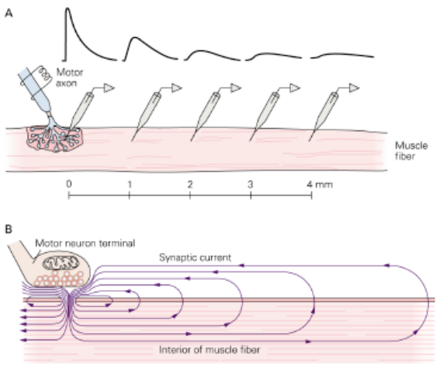
Passive Propagation of Synaptic Signals at the NMJ
- Neurons at the NMJ are also tubular, so the further away from the site of intiation you measure, the more the synaptic potential will have decayed.
- Another thing you should remember from Dr. Cooper’s section is charging and discharging the membrane capacitor
- Important to remember: Until you have charged up the membrane capacitor, you have a capacitative current. You cannot take a value for delta V during this time because it will be a mix of capacitative current and the current you are actually interested in. As soon as the capacitor is charged, however, capacitative current will be zero. (refer to Dr. Cooper’s section)

Spatial and Temporal Summation of Synaptic Signals
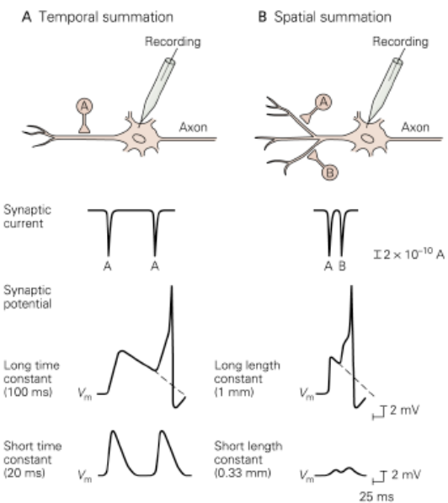
- Temporal Summation
  - Get input from a single synapse that fires more than once.
  - Net effect determined by time constant
    - Long time constant increases chances of summation.
- Spatial Summation
  - Get input from two or more synapses that are very close together.
  - Net effect determined by length constant
    - Long length constant increases chances of summation
- A question on this section could consist of being given the time constant or length constant and the time or distance between firing and calculating what the net effect is (AP or not).
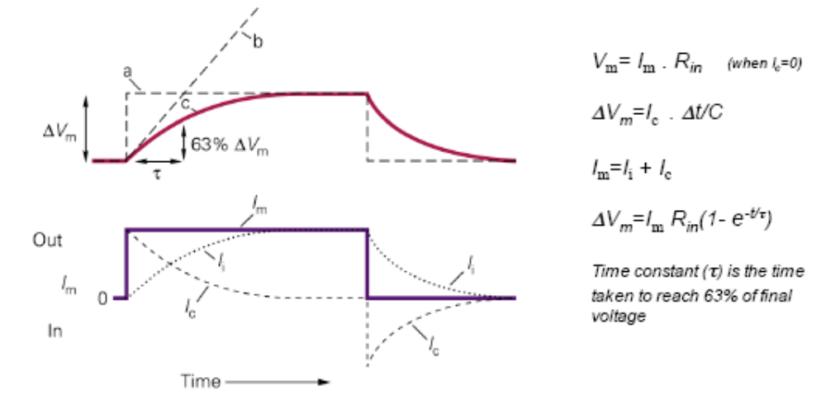

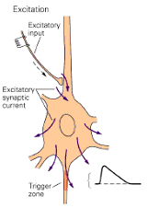
Summation of Synaptic Signals
- Excitation
  - An excitatory synapse right before the cell body is the most likely scenario for triggering an AP
  - Reversal potential for AMPA receptors is close to zero

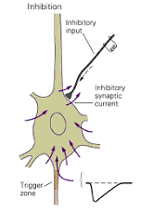
- Inhibition
  - Increases Cl– conductance, which hyperpolarizes the cell.
    - May do this by opening GABA channels and chloride conducting channels
  - Chloride reversal potential is just slightly more negative than membrane potential
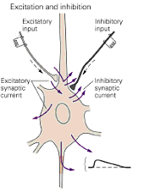
- Excitation and Inhibition
  - The inhibitory synapse attenuates the excitatory input.
  - Usually the excitatory input is larger than the inhibitory input because the higher reversal potential for excitatory synapses creates a much larger driving force for those synapses.

Steady State Ca++ flux through L-type Ca++ channels
- Certain cells have L-type calcium channels, through which there is a steady state calcium flux.
  - Depolarization enhances the flux, hyperpolarization decreases it.
    - The effect of hyperpolarization, even a small amount, is not just to counteract depolarizing current. It also decrease intracellular calcium concentration.
- As can be seen from the diagram, even a slight presynaptic hyperpolarization will decrease the amount of calcium entering the cell through L-type calcium channels. Consequently, as NT release is dependent on presynaptic intracellular calcium concentration, we will see a smaller postsynaptic EPSP.
- Slight presynaptic depolarization before the presynaptic AP is fired is enough increase intracellular calcium concentration enough to increase NT release such that the postsynaptic EPSP is above threshold.
  - This demonstrates the sensitivity of the release machinery to Ca++ levels
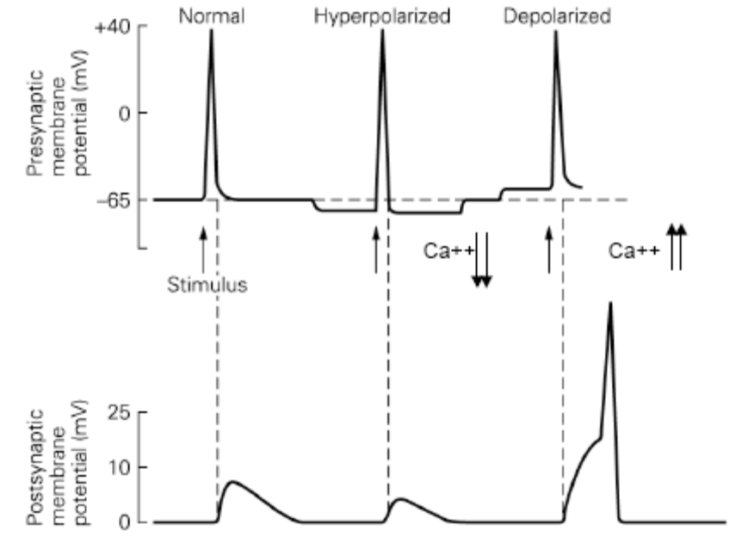

PHGY 311 – Lecture 20 October 30, 2006
Writer: Katie Turnbull Dr. Haghighi

Note about Monday’s Quiz:
- Questions will be focused on things from the second part of Haghighi’s lectures, but it will be impossible to isolate only the material from the second half.
- Questions will be all application, with no “direct questions” like the ones on the past quiz about synaptogamins and opening time for a channel.
- Last week focused on understanding the importance of synaptic integration and modulation.
    - The amount of NT released could be modulated by changing the calcium concentration, or affecting either the presynaptic terminals or postsynaptic receptors.
- Understand how synaptic potentials are generated, in terms of properties of the cell.

Synaptic Plasticity & Membrane Potential
- Chemical synapses can be modified by changing the resting membrane potential.
  - NT release is dependent on intracellular calcium concentration. A mechanism affecting presynaptic intracellular calcium concentration will affect the amount of NT released.

- Some cells have L-type calcium channels, through which a steady influx of calcium can enter the cell.
  - Changing the RMP will change the flow of calcium into the cell, and consequently influence NT release.
    - Calcium influx is enhanced by depolarization, and decreased by hyperpolarization.

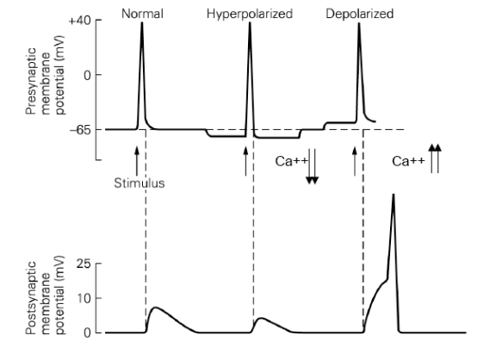
- At RMP, a presynaptic stimulus will give rise to a postsynaptic EPSP.
- If we hyperpolarize the cell, less calcium will flow through the L-type calcium channels. When we now apply the same stimulus, it will produce a smaller EPSP.
- If we depolarize the cell, more calcium enters the cell. We apply the same stimulus, the EPSP will be increased, perhaps above threshold.
  - Note that the AP is the result of voltage-gated channels, NOT ligand-gated channels.

- Steady state Ca⁺⁺ flux through L-type Ca⁺⁺ channels can influence transmitter release at rest
  - Small changes in RMP are enough to affect steady state calcium flux.
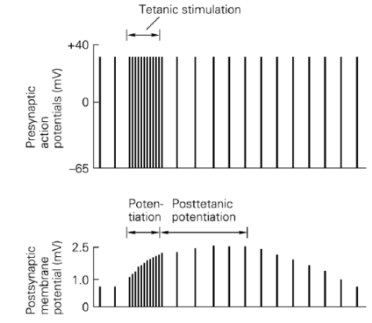
Synaptic Plasticity & Intense Activity
- The postsynaptic EPSP can also be altered by intense activity of the presynaptic cell.
  - Period of high-frequency presynaptic APs leads to progressively larger postsynaptic responses.
  - Larger response lasts until after presynaptic activity returns to normal.
- After a period of high frequency stimulation of the presynaptic cell (tetanus), there is an excess of calcium in the presynaptic terminal.
  - The excess is called residual calcium, and it can change the amount of NT released for many minutes after the titanic impulse.
- The postsynaptic potential remains elevated for several minutes, known as posttetanic potentiation.
  - The calcium buffering system is saturated, so the increase in calcium lasts, which increases NT release.
- In addition, residual calcium activates CaMKII by phosphorylating the synapsins.
  - CaMKII is an enzyme which enhances the ease by which neurotransmitter can be released. It releases the restraint normally put on NT vesicles, which makes it easier for them to be released.

Presynaptic Inhibition & Presynaptic Facilitation
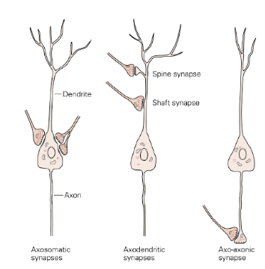
- There are several modes of synaptic contact. These include:
- Synapses on cell bodies
- Synapses on dendrites
- Axo-Axonal → In this case the axon is projecting to another presynaptic terminal. This is already the site of neurotransmitter release. These connections can directly affect the amount of neurotransmitter released.
  - Can result in presynaptic inhibition or presynaptic facilitation.
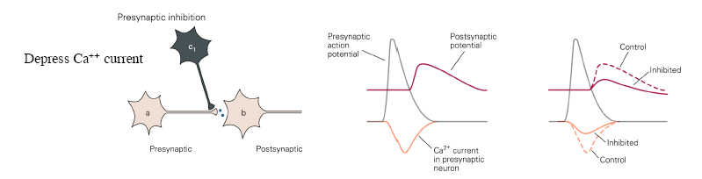

- Presynaptic Inhibition
    - An inhibitory neuron depresses the calcium current
      - Upon activation of the inhibitory neuron, the calcium current is reduced. The presynaptic AP remains the same, but the postsynaptic EPSP is reduced.
        - The total amount of neurotransmitter released is reduced

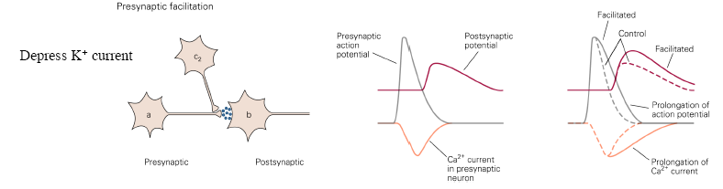
- Presynaptic Facilitation
    - An excitatory neuron depresses the K⁺ current.
      - When the K+ current is depressed, the AP lasts longer. Calcium channels are open longer, which allows a larger influx of calcium ions. This leads to more NT release, and then a larger postsynaptic response.
        - There is an increased EPSP.
    - This occurs because the presynaptic AP is falling slower, as K+ channels are depressed or shut.

- Possible Mechanisms of Inhibition
    - The activation of metabatropic receptors leads to the closure of Ca⁺⁺ channels and the opening of VGPCs.
      - Both act to decrease the amount of Ca⁺⁺ influx.
    - Activation of ionotropic GABA-gated Cl⁻ channels which short-circuits the AP in the presynaptic terminal.
    - The third mechanism is thought to work through metabatropic receptors by directly inhibiting the release machinery for neurotransmitters.

- Possible Mechanisms in Facilitation
    - Serotonin can act through cAMP dependent protein phosphorylation to close K⁺ channels, broadening the action potential and resulting in more Ca⁺⁺ influx.
    - Activation of ligand-gated channels such as nicotinic ACh receptors increases transmitter release possibly by depolarizing the presynaptic terminals.

Ionotropic & Metabotropic Channels
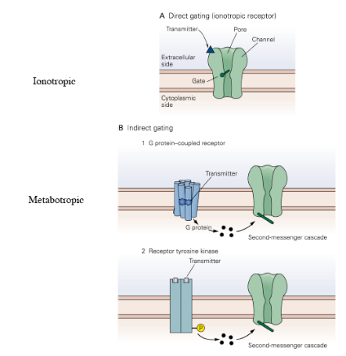
- Ionotropic Receptors: Consist of a single ion channel which is directly gated by the neurotransmitter. Ex. GABA, Glutamate etc

- Metabotropic Receptors: Cause a downstream change via a second messenger (most often a G protein). This opens an ion channel indirectly.
    - Metabotropic receptors can change the sensitivity of a cell without causing depolarization. So there will be a different change in response to the same amount of calcium.

Metabotropic Receptors

- Metabotropic receptors do not have an ion pore; they bind NT and cause a downstream change.
    - Usually (but not always) uses a second messenger.
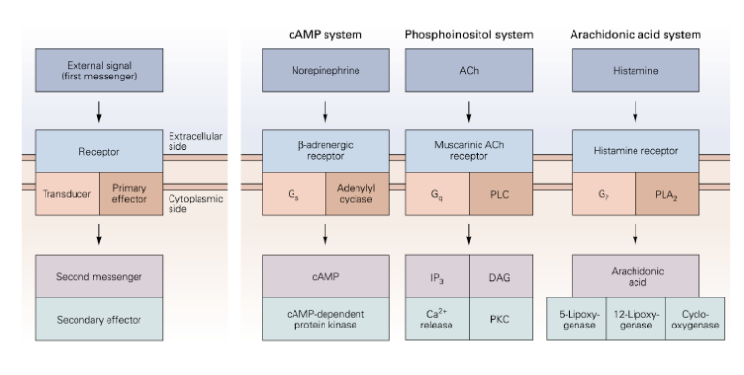
- The pattern is as follows:
    - Transmitters bind to their receptors and activate a transducer protein, which activates a primary effector enzyme.
    - This enzyme produces a second messenger that either acts directly on its target or that activates a secondary effector.

General Structure of GPCRs and Receptor-Ligand Interactions
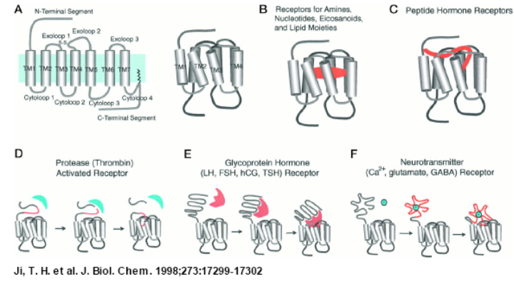
There are many different types of GPCRs (G-Protein Coupled Receptors). For example:
- D: This receptor needs to be “chewed up” by a protease to be activated
- E: Dr. Farookhi will talk a lot about this type receptor
- F: We will focus on this type of receptor which uses a neurotransmitter as its ligand.

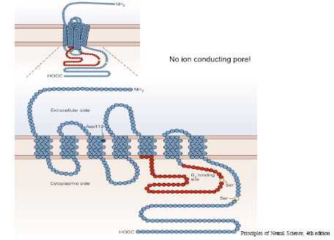
General Structure of GPCR
(β-adrenergic and Nicotinic Receptors)
- Contains seven membrane spanning domains.
- The dark blue Asp113 interacts with the neurotransmitter in the ECF.
- The brown/red loop is the part with which the G-protein associates.

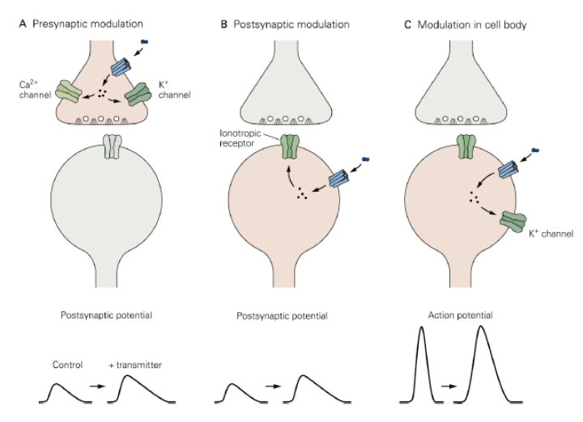
Second Messenger Action:
In general, there are 3 sites where second messenger can act.

a) Second messengers can act to affect Ca⁺⁺ of K⁺ channels by regulating the amount of transmitter released and the size of the postsynaptic potential.

b) Could affect ionotropic receptors which can alter the size of the postsynaptic potential.

c) Could affect a voltage gated K⁺ or Na⁺ channels involved in the AP.

Note: The diagram to the represents possible outcomes of the modulations described above. For all of these the opposite effect could occur.

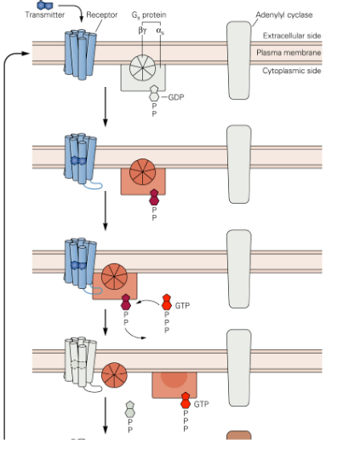
The cAMP Cycle

- Transmitter binds and alters the conformation of the receptor, which exposes the binding site for the G-protein.
- G protein associates with the receptor by diffusion, and it activated for GTP-GDP exchange.
- G protein alpha subunit is released and binds to adenylate cyclase, which becomes activated and produces many molecules of cAMP from ATP.
- General process by which cAMP levels rise.

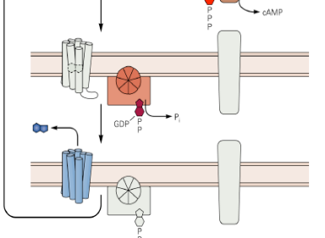
- The alpha subunit of the G-protein hydrolyzes GTP causing it to return to its original conformation and dissociate with the cyclase.
- This process is repeated until the neurotransmitter dissociates from the receptor, returning it to its original conformation.

- Even after NT has dissociated from the receptor, increased cAMP levels can last a lot longer.

cAMP Pathway
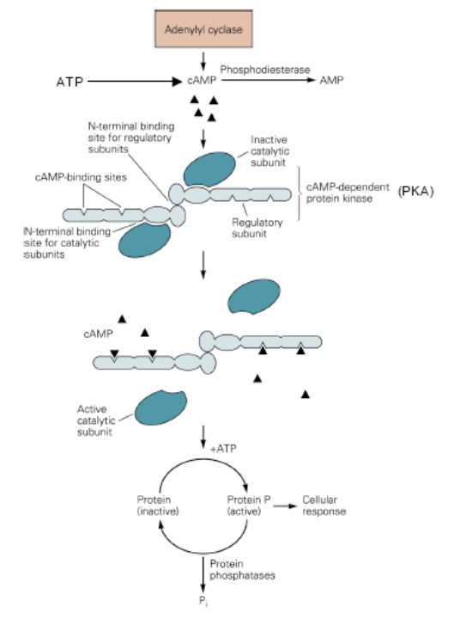
    - Adenylyl cyclase converts ATP into cAMP as we saw above.

    - Four cAMP molecules binds to the c-AMP-dependent protein kinase (PKA) thus liberating the catalytic subunits.

    - The now active catalytic subunits can go and activate (by phosphorylating) a particular target protein in order to regulate a cellular response.

Two enzymes regulate this pathway:
1) Phosphodiesterases: convert cAMP to AMP
2) Phosphotases: Remove phosphate groups from the substrate proteins.

Actions of cAMP
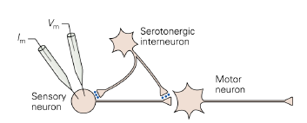
- Consider a serotonergic interneuron making synaptic connections on the axon terminal and cell body of a sensory neuron. The sensory neuron has an excitatory synapse with a motor neuron.
  - The serotonergic neuron can affect the cell body and axon terminals, which leads to closure of S-type potassium channels. The membrane potential will be more depolarized and the response is increased.
    - Potassium channels are closed, which increases resistance, so voltage (V=IR) is increased.

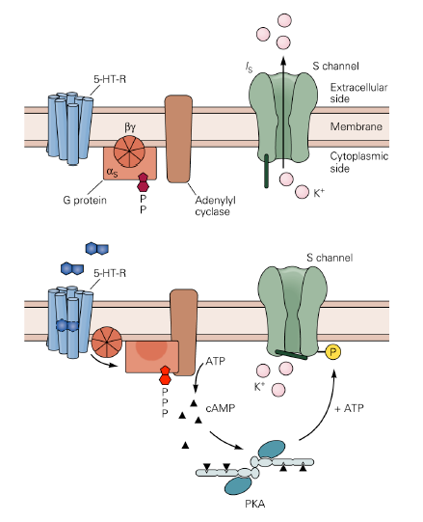
- This is the mechanism by which cAMP becomes active, which activates PKA. cAMP can modulate closure of S-type potassium channels in the Aplysia sensory neurons.

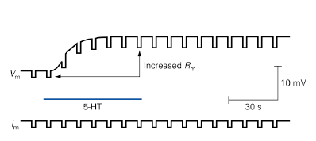
- Activation of the Metabotropic Receptor by 5-Ht (serotonin) causes the release of cAMP and the activation of PKA. PKA phosphorylates the K⁺ channel, thus inactivating it.
- This causes the membrane to be less leaky and causes the membrane to be slowly depolarized. This is due to a decrease in membrane conductance.
- Increase in resistance (due to shut potassium changes) increases the amount of depolarization for the same change in current.

PKA Activity
- PKA can do a variety of things. In the example we’ve been studying, PKA activity leads to a closure of S-type potassium channels.
- When we look at a patch clamp recordings of S-type K⁺ channel activity, we find that single channel activity is now affect.
  - Activity is much reduced when 5-Ht is expressed

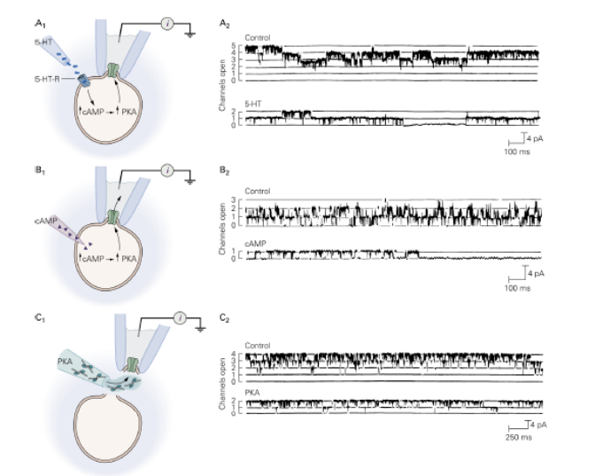
A – Addition of 5-Ht decreases the probability that a channel will open. Channels are opening with the same conductance, but they are less likely to open.

B – In this experiment, the researchers wanted to confirm that serotonin was working through cAMP. The results showed that injection of cAMP into the cell caused the same effect.

C - In this experiment, the researchers wanted to confirm that cAMP was activating PKA, which was directly influencing the receptor opening.

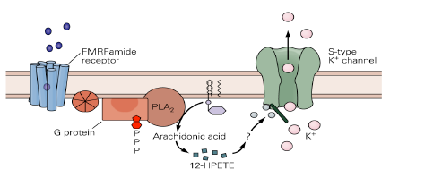
FMRF-amide

- FMRF amide affects the same channels, but it goes through a different G-protein cascade.
  - Cascade activates arachidonic acid, and now potassium channels can be activated.
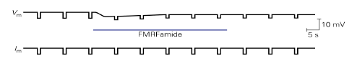
- Experiments show that FMRF-amide increases the probability that a channel will open.
  - It acts through the arachidonic acid pathway to counteract the action of serotonin through 12-HPETE.
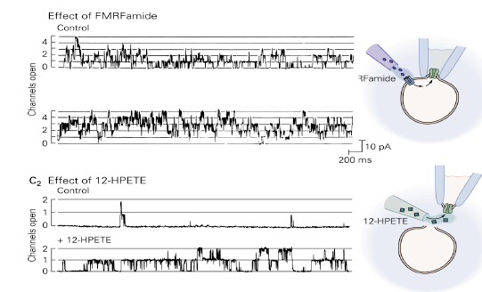

- As in the experiment above patch clamp experiments were done to test that indeed 12-HPETE and FMRF are important to this pathway. The experiments show that both FMRF and 12-HPETE were essential to opening the S-type channels.

Short and Long Term Effects of Second Messengers
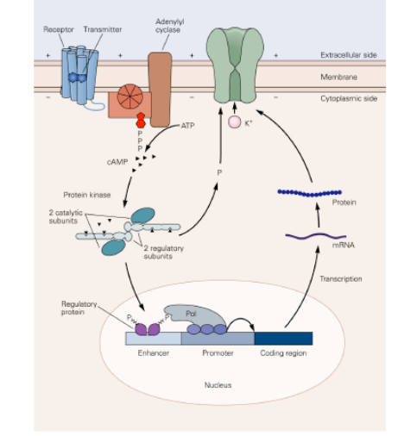
- Outlined above are the short term effects of second messengers.
- Second messengers can also affect the cell long-term. This is done through the regulation of transcription of important genes. This can change neuronal excitability for days or weeks.

